[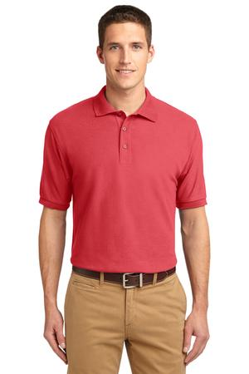](javascript:document.Form1.imagesearch.value='yes';submitForm1('53829','','','imglib/catl/2014/f17/K500_hibiscus_model_front_072014.jpg','300','400',%20'',%20'');)1

Purchase your TBPH 20th Birthday Embroidered Shirt TODAY!!!

Name: ____________________________

E-mail: ____________________________

Phone: ____________________________

**Men:**

Quantity _____ Size: S M L XL XXL XXXL XXXXL XXXXXL

**Women:**

Quantity _____ Size: S M L XL XXL XXXL

Amount paid: _______________

Shirts are $25 a piece.

Add additional $3 for 2XL, $4 for 3XL, $5 for 4XL & $6 for 5XL

Deadline to order is at meeting on 8/20/14 or

Send checks to TBPH, P.O. Box 89912, Tampa, FL 33689 to arrive by 8/25/14

