**C:\Users\Owner\AppData\Local\Microsoft\Windows\Temporary Internet Files\Content.IE5\HGNKTO8W\MC900295595[1].wmfDon’t miss the Boat! C:\Users\Owner\AppData\Local\Microsoft\Windows\Temporary Internet Files\Content.IE5\HGNKTO8W\MC900295595[1].wmf**

**Tampa Bay Parrot Head Cruise**

**  **

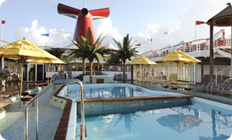  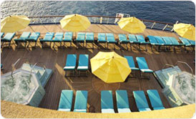

**May 7 through 11, 2015 (4 nights) – Aboard Paradise, Itinerary: Tampa, Fun Day @ Sea, Cozumel, Fun Day @ Sea and return to Tampa.**

***Pricing for Florida Residents/Early Saver with Price Protection:***

**$818.96 - Interior Room for 2, higher for up to 4. Port Charges Included**

**$898.96 – Ocean View-Port Hole for 2, higher for up to 4. Port Charges Included**

**$1358 – Grand Suite – for 2, higher for up to 4. Port Charges Included**

***Down Payment – Deadline is Sept 30th:***

**$150pp. NON/refundable but transferable for a later date. Final Payment due: 3/8/15**

**Contact: Carnival @ (866) 721-3225 – Option#3. Ask for the**

**Tampa Bay Parrot Head Club Group Booking #: 2T8PD8**

**“Have your friends book their cabins at this number to have your reservations tied together.”**