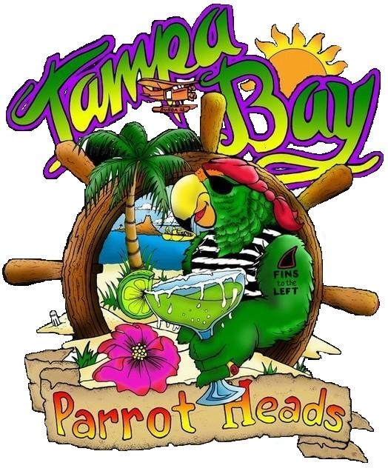

TAMPA BAY PARROT HEADS IN PARADISE FUNDRAISING EVENT

CELEBRATING 21 YEARS

Tampa Bay Parrot Heads “party with a purpose: and will be hosting a weekend-long fundraiser at the Holiday Inn Harbourside on beautiful Indian Rocks Beach to support two of our favorite charities, Clearwater Marine Aquarium and Tampa Bay Watch. Friday evening we are hosting a Raffle for Clearwater Marine Aquarium and on Saturday a Silent Auction for Tampa Bay Watch.
Our club is successful because of the individual Parrot Heads and local businesses that support us and our enthusiasm to become involved with community projects related to improving the environment in which we live. Our projects and friendships have cemented the bonds between us.
All donations will be greatly appreciated and yours can go far to assist us in living Tampa Bay Parrot Head Club’s motto, “Let’s leave the world a little better than we found it….and have a BLAST DOING IT”! You can give your donations to one of our club representatives or mail it to the PO Box address listed below. We will be happy to advertise your generosity at our event.
Tampa Bay Parrot Heads in Paradise Club, Inc. is a Florida 501(c) (7) non-profit social club and the address is PO Box #89912, Tampa, FL 33689. Monies from raffles and auction items at the event will be paid directly to Clearwater Marine Aquarium and Tampa Bay Watch. Clearwater Marine Aquarium & Tampa Bay Watch are 501(c) (3) tax exempt nonprofit organizations, so your donations are usually fully tax-deductible. Please consult your tax advisor as to the tax status of your donation or contribution to this event.
Thank you in advance for your donation.

Sharon Leverett

Chief Officer of Charities

Tampa Bay Parrot Heads in Paradise Club, Inc.

