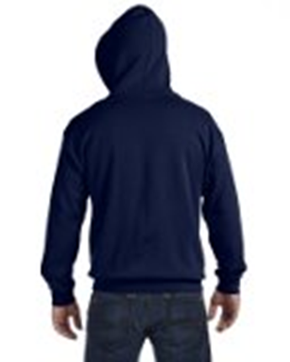

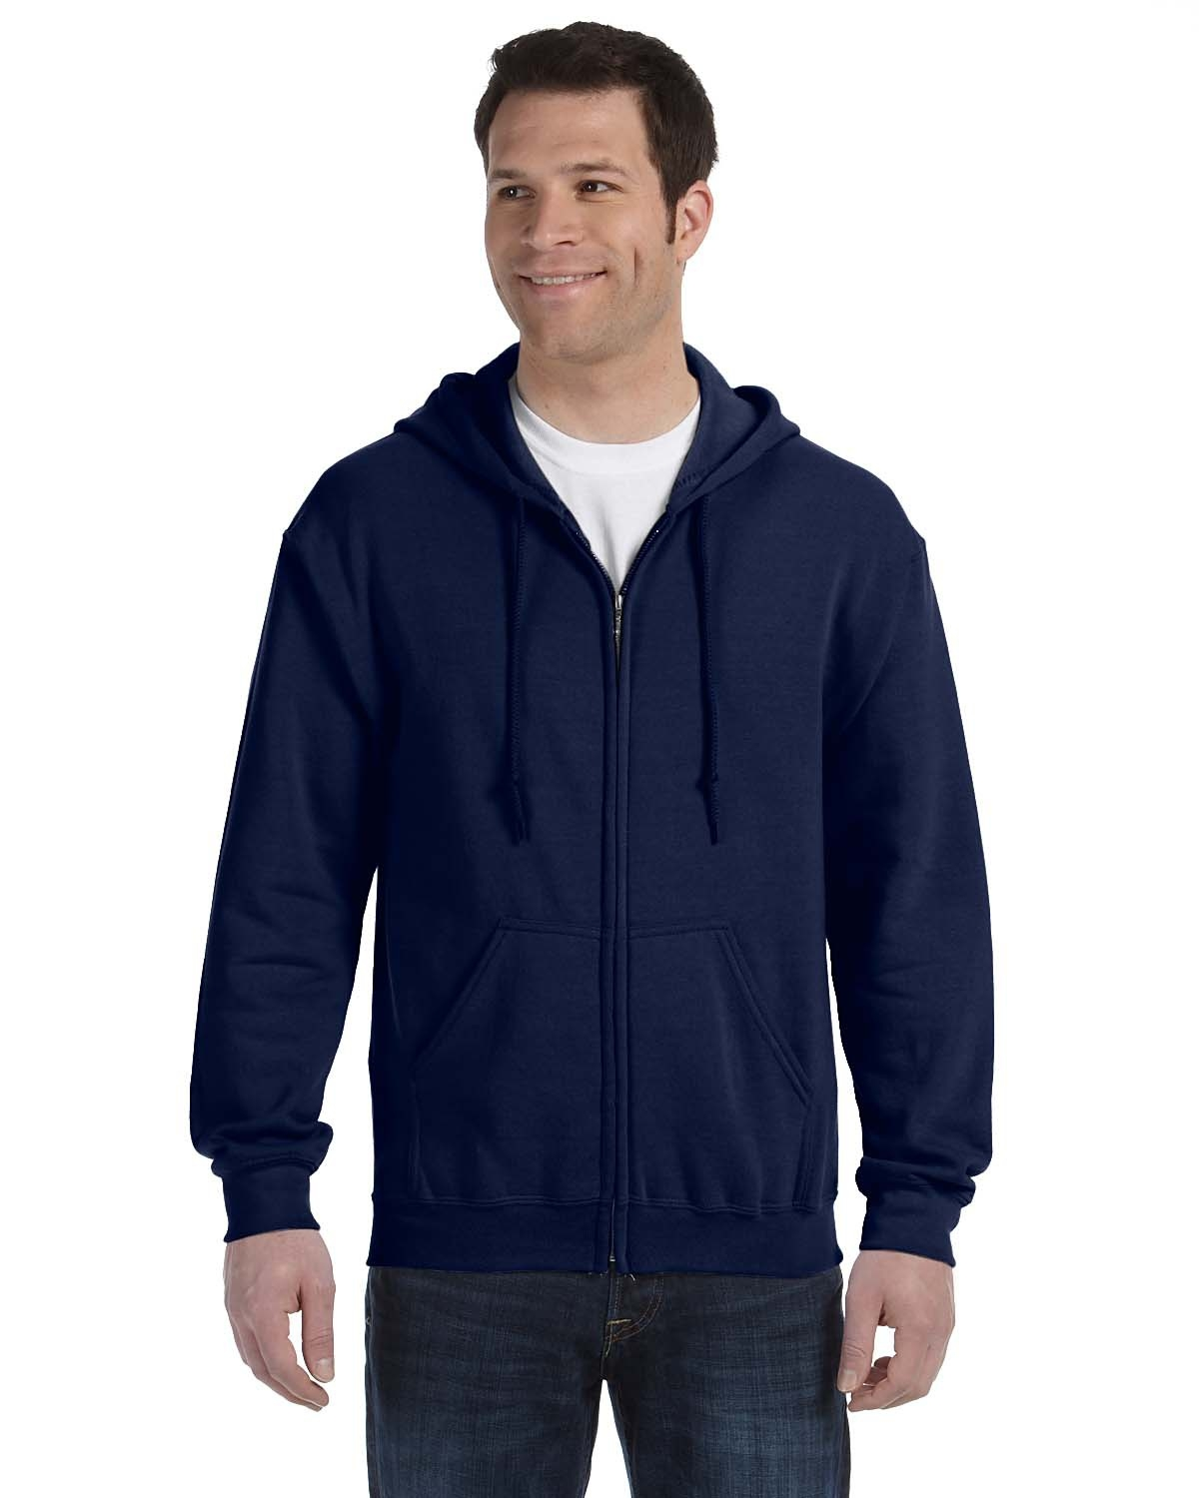

Tampa Bay Parrot Heads Sweatshirt

Navy Blue, hooded, front zippered

TB PH

**Order**

**your TBPH Sweatshirt**

**today!**

**Name: _____________________________________________**

**E-mail: ­_____________________________________________**

**Phone: _____________________________________________**

**Men’s Sweat-shirt $27 sizes Small to Large / $29 size 2XL / $31 size 3XL / $33 size 4XL**

**Men’s Sweat-shirt: Quantity:_________ Size: __________ Price: $___________**

|  |  |  |  |  |  |  |  |
| --- | --- | --- | --- | --- | --- | --- | --- |
|  | S | M | L | XL | 2XL | 3XL | 4XL |
| Chest | 38-40 | 42-44 | 46-48 | 50-52 | 54-56 | 58-60 | 60-62 |

**Order and Payment Deadline is 2/3/16 meeting**

**Make checks to arrive no later than 2/3/16. Mail to:**

**TBPH**

**PO Box 747**

**Tampa, FL 33548**