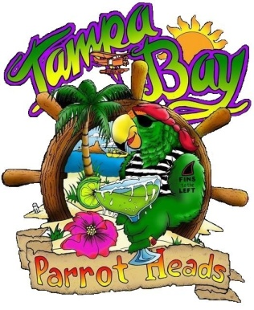

In an effort to make the club more exciting and about our members, we have a few questions to ask you.
- What event is your favorite? __________________________________________

- What is your least favorite event? ______________________________________

- What event would you like to see TBPH have? ____________________________

Comments: __________________________________________________________________
____________________________________________________________________________
____________________________________________________________________________

Did you attend the Shark Tooth Festival? _________ Yes _________ No
If not, why? __________________________________________________________________
Did you attend the Bar Stroll? _________ Yes _________ No
If not, why? __________________________________________________________________
Did you attend the Birthday Bash? _________ Yes _________ No
If not, why? __________________________________________________________________
Did you attend the Holiday Party? _________ Yes _________ No
If not, why? __________________________________________________________________
Please fill out and place in the envelope on the stage.

