Music on the Bay
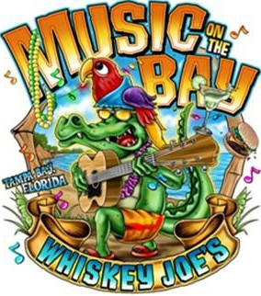

Mar 2 – March 5, 2017

Whiskey Joe’s Barefoot Beach

7720 W Courtney Campbell Causeway

Tampa, Florida 33607

Mail-in Event Registration

Pre-Registration Fee $80.00 per person • One Form per person

* * * After January 15,2017 • $90.00 per person & No Goody Bag * * *
Includes admission to event for four days, Goody Bag, and Shuttles running between Host Hotels and Venue
First Name:
Last Name:
Club Affiliation:
Address:
City:
State:
Zip Code:
Cell Phone:
Home Phone:
email Address:
Date Arriving:
I would like to Volunteer for: Make check payable to: Music on the Bay
Registration
Raffle
Information Tent/First Aid
Security
Anywhere I’m needed

Mail to:

Music on the Bay c/o TBPH
PO Box 747

Lutz, Florida 33548
*** No Refunds * ** Not Transferable ***

All funds from cancellation will be donated to Shriners Hospital for Children. Music on the Bay is an Adult Event- Attendees must be 21 Years Old to attend.
No Inappropriate Attire Permitted- Violating Attendee will be escorted out of event.

No Personal Liquor or Ice Chests/Coolers will be allowed.
On line Pre-Registrations will be accepted until February 12, 2017

