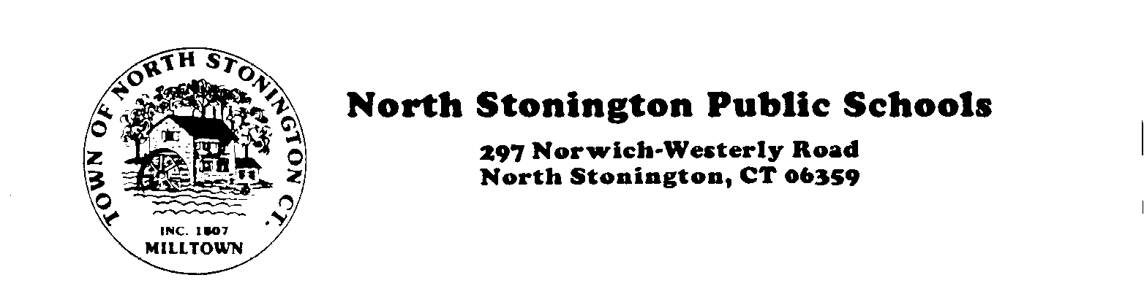
(860) 535-2800 Fax (860) 535-1470

January 16, 2018

NOTICE OF VACANCY

Long-term Substitute - Elementary Library/Media Specialist – North Stonington Elementary School. Candidate must have Connecticut certification 062 endorsement. ELA instruction experience is preferred. Expected start date is February 21, 2018, through the end of the school year.

Interested persons should contact Veronica Wilkison, Principal, North Stonington Elementary School, at 860-535-2805. Open until filled. EOE.

North Stonington Public Schools does not discriminate in any employment practice, education program, or educational activity on the basis of race, color, religious creed, sex, age, national origin, ancestry, marital status, sexual orientation, gender identity or expression, disability (including, but not limited to, intellectual disability, past or present history of mental disorder, physical disability or learning disability), genetic information, or any other basis prohibited by Connecticut state and/or federal nondiscrimination laws. North Stonington Public Schools is an EOE. Inquiries regarding North Stonington Public Schools’ nondiscrimination policies and practices should be directed to: Ryan Chaney, Associate Principal, Wheeler High School/Middle School, 298 Norwich-Westerly Road, North Stonington, CT. Tel: 860-535-0377.

