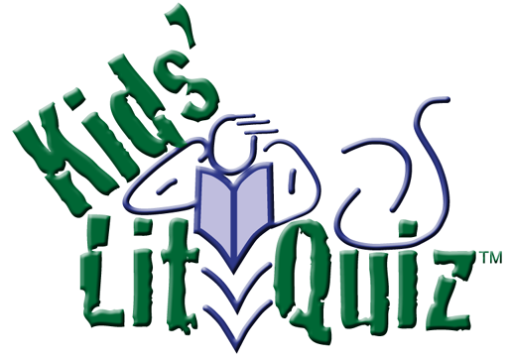
Kids’ Lit Quiz™ Pre-test 2025
These 50 pretest literary questions are supplied to assist you with your team selection for the Kids’ Lit Quiz™.
Note: It is intended that these questions be asked of a team rather than individually. They act as a guide only; further consultation with the school librarian, the child’s teachers and caregivers will also assist selection. Every year a new set of pretest questions is prepared for teachers to add to questions from previous years.

1 What food did Goldilocks enjoy eating? [Porridge]
2 What was the name of the Roald Dahl book about a young boy and his Norwegian grandmother? [The Witches]

3 What creatures pulled the White Witch's sled? [Reindeer]

4 What Scottish monster supposedly has a massive body, a long snake-like neck and a small head? [Loch Ness Monster]

5 Beater, Chaser, Keeper, & Seeker are positions in what game? [Quidditch]

6 Spot saved the two sycamore seeds in Brian Selznick’s book Big Tree. What type of winged insect was Spot [Butterfly accept Lacewing]

7 What monster married the ugliest princess on the planet and lived horribly ever after? [Shek]

8 Who was the shopkeeper in the David Walliams books that tried to sell items past their used by date? [Raj]

9 How did Jack kill the giant? [He cut the beanstalk as the giant was descending]

10 All the characters in Harry Potter were fictional except for one who actually lived in the fourteenth century. Who was that? [Nicolas Flamel]

11 King Fred and the citizens of Cornucopia loved Bertha Beamish’s Maiden’s Dreams, Fairies’ Cradles and most of all Hopes-of Heaven. What type of food were these three treats in the book Ickabog? [Pastries]

12 In the book 96 Miles the kids talk about what monsters to pass the time walking? [Zombies]

13 Who was Red Riding Hood going to visit? [Her grandmother]

14 To whom is this referring? A boy who won’t be good might as well be made out of wood. [Pinocchio]

15 In a Pueblo folk tale a young boy asked for help to find his father because he was being teased by the other boys. It was titled Arrow to the blank and won the Caldecott Medal for its illustrations in 1975 [Sun]

16 In Winnie the Pooh whose favourite food was thistles? [Eeyore]

17 A haiku has how many lines? [Three]

19 Whose father called her Soybean when she was little ? [Sophie Foster]

20 What would happen if you stared at Medusa? [You’d turn into stone]

21 Who fell in love with his reflection? [Narcissus]

22 Who was the leader of the Lost Boys? [Peter Pan]

23 Mary’s little lamb followed her to where? [School]

24 What kind of sandwiches were Paddington’s favourite? [Marmalade]

25 What was Mr Terrupt’s occupation? [Teacher]

26 What did the mouse run up? [The clock]

27 What was the name of Snow White’s sister? [Rose Red]

28 What eccentric chocolate maker made dreams come true? [Willy Wonka]

29 What did the Little Red Hen bake? [Some bread]

30 In the 2023 Caldecott Medal winning book, Watercress, the power of memory transported the family back to what country? [China]

30 Who lost his hand to a crocodile? [Captain Hook]

31 What was the name of Professor Dumbledore’s phoenix? [Fawkes]

32 What ancient Greek writer usually featured animals in his fables? [Aesop]

33 Starting with A which girl is the youngest in Little Women? [Amy]

34 In what folktale do stepsisters cut off their toes to fit a shoe? [Cinderella]

35 Which character in Fantastic Beats has an expanding suitcase? [Newt Scamander]

36 Sharon Draper wrote Out of My Mind about Melody Brooks, a girl with cerebral palsy. Her next book also about Melody, was titled Out of My what? [Heart]

37 Rick Riordan created the mortal character Lester Papadopoulos who was really the Greek god named whom? [Apollo]

38 What award-winning -picture book begins with: A mouse took a stroll through the deep dark wood. [The Gruffalo]

39 Who is the subject of the book Brown Girl Dreaming? [Jacqueline Woodson]

40 The Ali Cross series by James Patterson is about a wannabe boy detective and are all set in what district? [Washington DC]

41 What was the first creature Heracles had to kill? After killing it he then wore its skin. [A lion accept Nemean Lion]

42 What monster is Ham Helsing hunting? [Vampire]

43 Sounder by William H Armstrong is what type of animal? [Dog]

44 Who was The Prisoner of Azkaban? [Sirius Black]

45 How many Hunger Games were being celebrated in Book One [74]

46 What name is given to a figure of speech that uses like or as? [Simile]

47 The Boy Who Got Accidentally Famous had a very ordinary name, His father was John Smith, what was the boy’s first name? [Billy]

48 The curious Australian dog Bluey has what last name? [Heeler]

49 Who followed a rabbit into its warren [Alice]

50 Who were the two children that tried to make their way back home even though they’d been deliberately abandoned by their parents? [Hansel & Gretel]

For further information on the Kids’ Lit QuizTM

Please visit the international website: kidslitquiz.com

.

