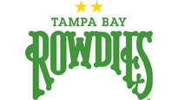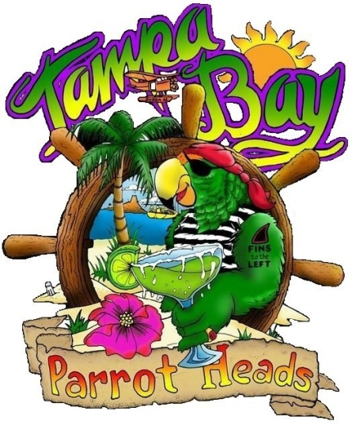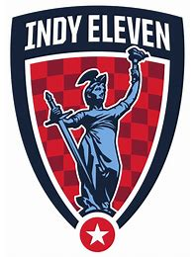
Saturday, October 12th
Kick off 7:30pm
Al Lang stadium

Cost: $23.00 p/p

PreGame Meet-up @ TBD

This is a wrist-band Event!

Pre-game tailgate area, Margarita specials and more!

Depending on how may tickets we sell TBPH will get special tailgate area, video recognition, and pictures on the field with the players after the game!
Contact: Jorge @ tpaboatdrinks@gmail.com
or pay at upcoming meetings through June 19th

