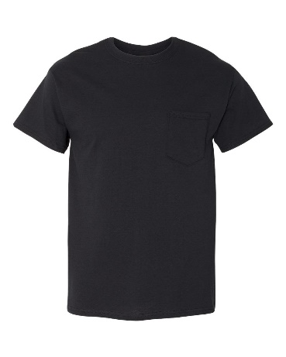

Purchase your “25 Trips Around the Sun” TBPH Birthday T-shirt TODAY!!!



Name: ____________________________

E-mail: ____________________________

Phone: ____________________________

**Shirt is Black with Silver verbiage and Logo**

**Front: TBPH**

**25 Trips Around the Sun**

**Back: TBPH Logo**

**1994-2019**

**Men:**

Quantity _____ Size: S M L XL 2XL 3XL 4XL 5XL

**Women: V-neck**

Quantity _______ Sizes: S M L XL 2XL 3XL 4XL

Amount paid: _________

Shirts are $20 apiece.

Add additional $3 for 2XL, $4 for 3XL, $5 for 4XL & $6 for 5XL

**Deadline to pre-order at a meeting on 8/21/19**

or Send checks to

TBPH, P.O. Box 747, Lutz, FL 33548 to arrive by **8/19/19**